**Output:**

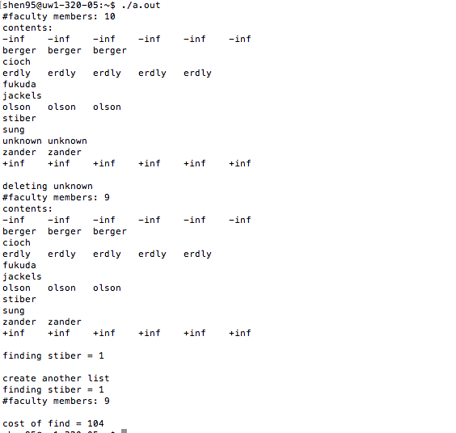

**Performance:**

Macintosh HD:Users:jamesshen:Desktop:屏幕快照 2017-05-15 12.05.59 AM.png

**Performance Consideration:**

I compiled the code with 10000 random numbers. It turns out that the mtflist is the fastest. The skiplist is slower than mtflist, but it faster than dlist and translist. The skiplist cost 2013580 operations more than double-linked list. The double-linked list cost 6491439 operations, and transpose-linked list cost 6422436 operations. The expected time to find an element and therefore to insert or delete an element using skiplist is O(logn). In an ordinary sorted linked list, find, insert, and remove are in O(n) because the list must be scanned node-by-node from the head to find the relevant node. Since skipped list has up and down, we could scan down the list in bigger steps we would reduce the cost of scanning.